1. Register an account with GitHub at the following link: <https://github.com/signup>
   1. Sign up with an email you will have access to after you graduate, such as your personal email. Do not use your school 06 email address, as you will not be able to access this after you graduate, nor will you be able to verify your account with it.
   2. Set an appropriate username! Your employers will see this. But don’t worry, as you can freely change your username after registration.
   3. You will be asked to provide a code sent to your email to complete registration.
2. After registering an account, you will be asked to login with the credentials you provided.
3. Once you log in, you will be met with the GitHub Dashboard. While it may seem daunting, it’s simpler to understand than you may think.
   1. At the top, there is a Copilot chat so you can talk to LLMs about the GitHub platform
   2. In the middle, you’ll find various guides on how to use GitHub and its various features.
   3. On the left sidebar, you’ll see the option to create a repository: a place your code and programs go.

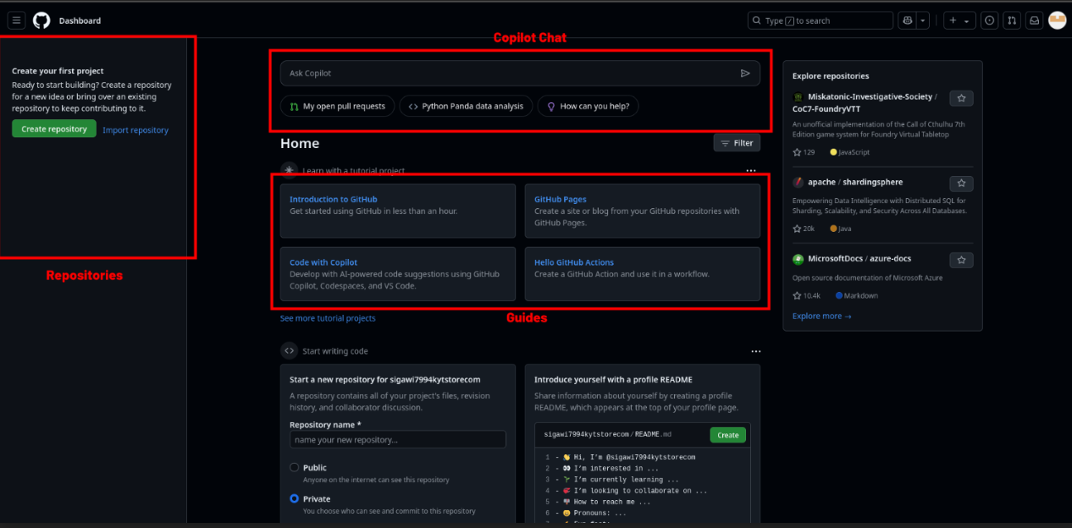

1. For now, your primary goal is to customize your account and tell who you are.
   1. At the very top right, you’ll see your profile picture. By default, it will be a colorful pattern of shapes.

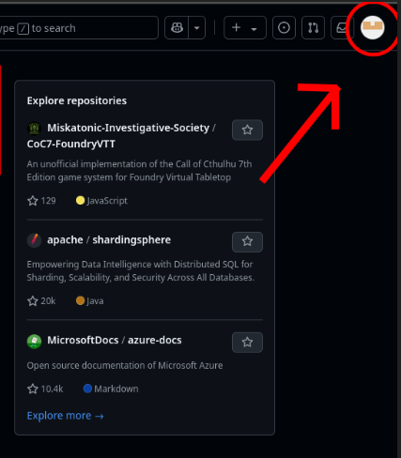

* 1. Click on it, and a sidebar will open up.
  2. Within this sidebar, select the “Settings” button.

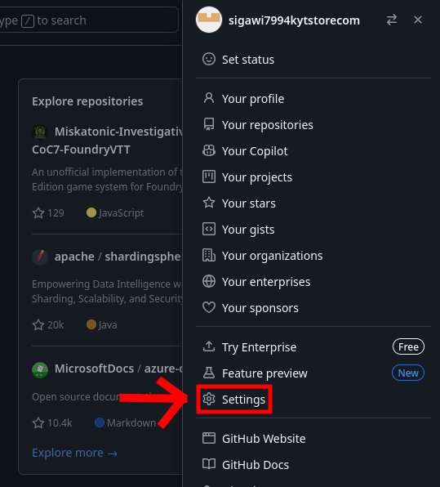

* 1. You will be brought to a page to edit your profile.
  2. Here, you can enter your name in the “Name field”, set your email to public, create a biography about yourself, set pronouns and set a profile picture. The profile picture should look professional, as this is what recruiters will see on your profile.

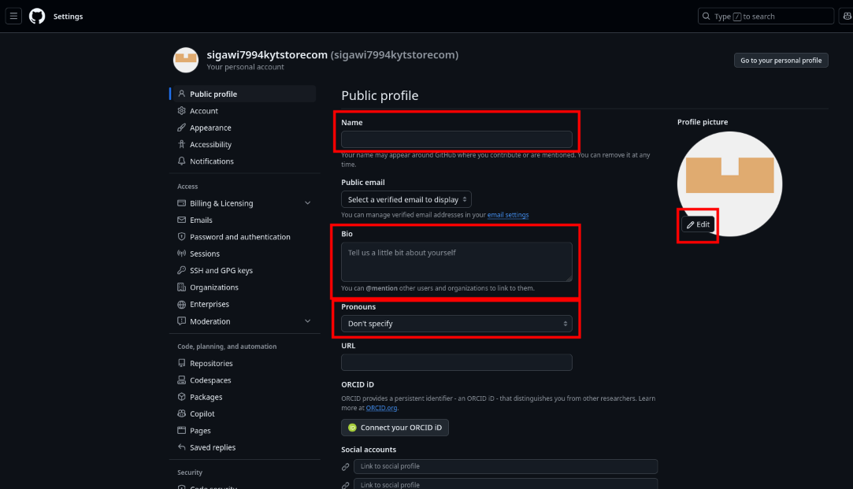

* 1. Tell a short summary about yourself in the biography field, like who you are and what you do. You may use an AI LLM chatbot like copilot to help.

1. After modifying your profile settings, you have one last step to fully complete your profile: Introduce yourself through a README file.
   1. Return to the dashboard by clicking the GitHub icon in the top left (will look like a cat).
   2. In the center of the page, there will be a module that says “Introduce yourself with a profile README”
   3. Click the green “Create” button.

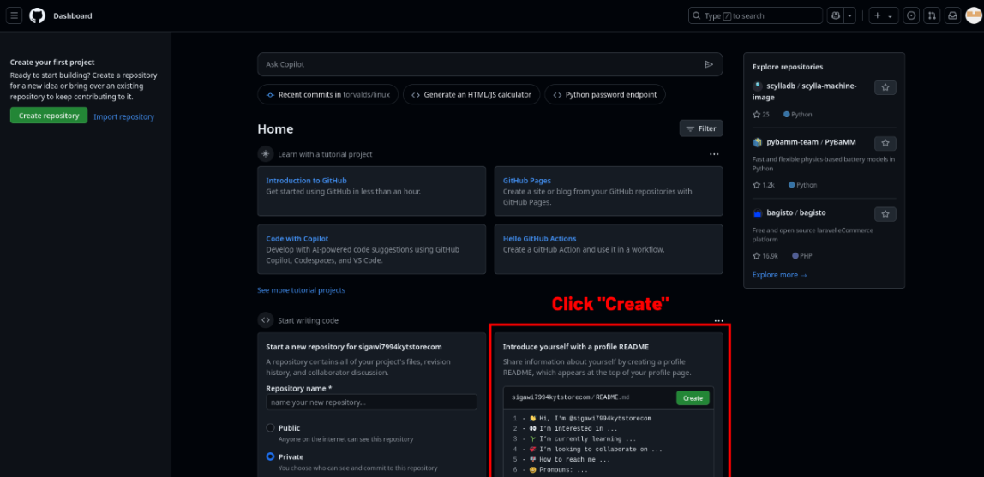

* 1. After doing so, you will be brought to a text editor to create the README file.
  2. Go onto a website such as <https://pandao.github.io/editor.md/en.html>
     1. GitHub uses a language called Markdown to format text (e.g. bold, italics, bullet points).
     2. The website above can be used to create a Markdown file.
  3. After creating your Markdown text with the website, paste it into the GitHub text editor.
  4. After you’re finished, click “Commit changes” twice.

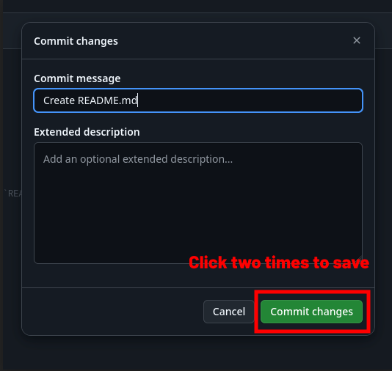

1. Your profile is now fully personalized, you can check how it looks at any time by clicking your profile icon at the top right and clicking “Your profile”!

# Creating your first repository

Repositories are used to store and document the work you do. Employers will check your GitHub profile to view what experiences you have, so it’s important to create repositories for your GitHub account. You must create these four repositories on your account (for grade):

* Awards
* Industry Certifications
* Presentations
* Labs

Do the following:

1. Return to your GitHub dashboard if you are not on it.
2. On the left sidebar, you will see your current repositories. You may already have automatically created one when you made the README in a previous step.
3. Click “New” to create a new repository.

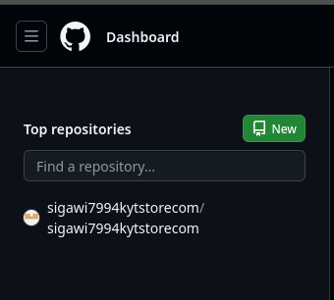

1. You will be introduced to a screen to create your repository:

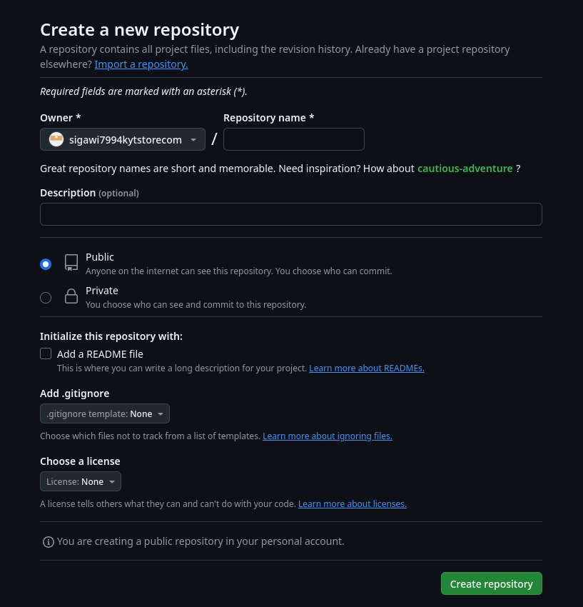

1. Give your repository a relevant name and description of the project you wish to document.
2. Choose “Public” to ensure it is visible to people who may visit your profile.
3. Check “Add a README file”
4. Click “Create repository”
   1. You have now created your first repository!

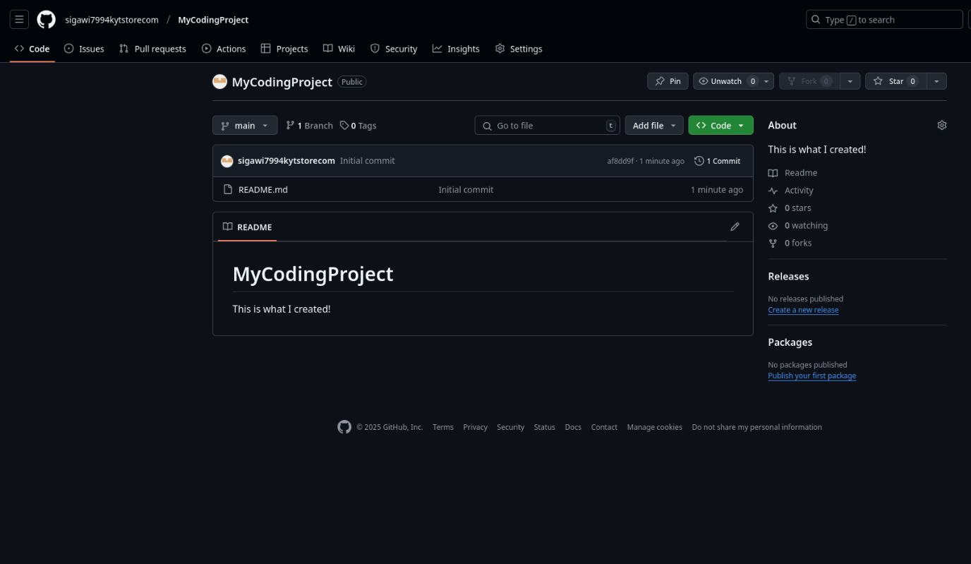

1. This is what you’ll see after creating your project. You will see the name and description you gave it.
2. After creating your repository, you will notice it is empty. You will need to upload the files of your project to the repository, such as images, presentations, etc...

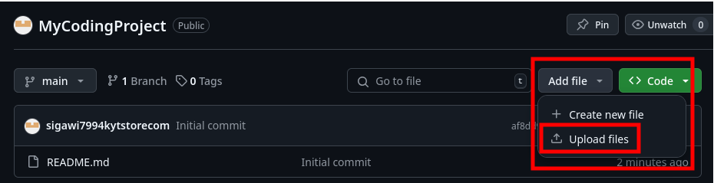

1. Click on the” Add file” button and select ”Upload files,” this will be how you get your project onto the repository. Name the files meaningfully as some recruiters review them by name, and may not even open them if their names are not meaningful.
2. You will be prompted to select all the files you wish to upload, do so now.
3. After you have finished uploading your files, click “Commit changes”

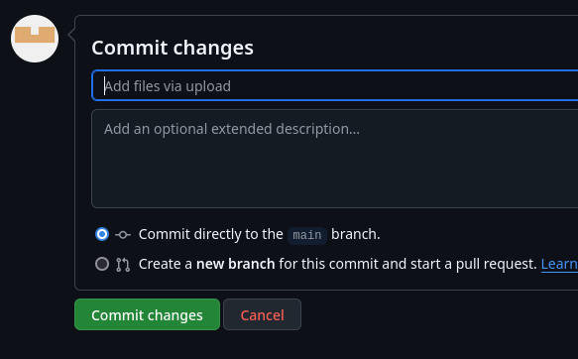

1. It will now show up on the repository.

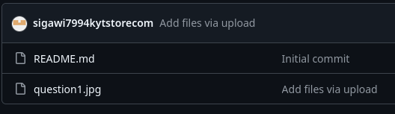

(I uploaded question1.jpg)

1. If you ever wish to change the description of your project, you can edit the README file for that repository.

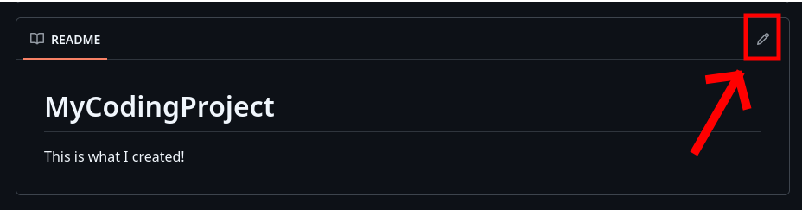

* 1. Like earlier, you can use a markdown editor like <https://pandao.github.io/editor.md/en.html> to make it look nice.
  2. You can also add images to your README by pasting them directly into the GitHub editor.

1. Make sure you end with at least the repositories below, filled with pertinent files:

